Threat Prioritization
Candidate Ranking Procedure

Revision
Version 1
7/28/26 10:22 AM

Author
Charles Wilson

Abstract
This document describes the procedure used to perform the threat candidate ranking activity described in the AVCDL ^{[1]} Threat Prioritization Plan ^{[2]} secondary document.

Group / Owner
Security / Security Architect

Motivation
This document is motivated by the need to have formal processes in place regarding the disposition of cybersecurity-related threats in the context of the development of safety-critical, cyber-physical systems.
Note: Within the context of this document, the terms security and cybersecurity are used interchangeably. It is presumed that the term security is being used in reference to cybersecurity and not physical security.

License
This work was created by Torc Robotics and is licensed under the Creative Commons Attribution-Share Alike (CC BY-SA-4.0) License.
https://creativecommons.org/licenses/by/4.0/legalcode

Audience
The audience of this document is the cybersecurity practitioner who will be conducting the threat candidate ranking activity within the threat prioritization process.

Completeness of Output
Since threat candidate ranking is an as-is analysis, it is critical to ensure that the information gathered is as accurate and complete as possible. As with any cybersecurity assessment, it is not the place of the security SME to make assumptions on the part of engineering. All information should be sourced from and confirmed by the owner of the element under consideration.
When information is not available for either a given section of the template or parts thereof, this should be noted. Major omissions should be recorded in the cybersecurity risk register.

Disposition of Output
The output of this activity is used as input to the threat candidate risking activity.
This activity does not generate any materials used as documents of record.

Entry Criteria
This document assumes that the reader understands the purpose of threat candidate ranking. Further, that the reader has read and understood the AVCDL Theat Prioritization Plan secondary document.

Prerequisites – Security SME

Qualifications
It is required that the security SME is both a qualified and trained security architect (shown above on title page as Owner) as defined by the NIST NCWF role SP-ARC-002 and detailed in the NCWF Roles - Security Architect section of the AVCDL Background Material elaboration document ^{[3]}.

Knowledge
It is required that the security SME understands the purpose of threat candidate ranking.

Background Information
It is required that the security SME has read and understands the AVCDL Threat Prioritization Plan secondary document. Additionally, that the security SME has taken training relevant to this activity.

Prerequisites – Input Materials
It is required that the security SME acquire any documentation relevant to the threat candidates under consideration necessary to complete the procedure.

Candidate Ranking Activity
The workflow diagram for the threat candidate ranking activity of the Threat Prioritization Plan is shown below.
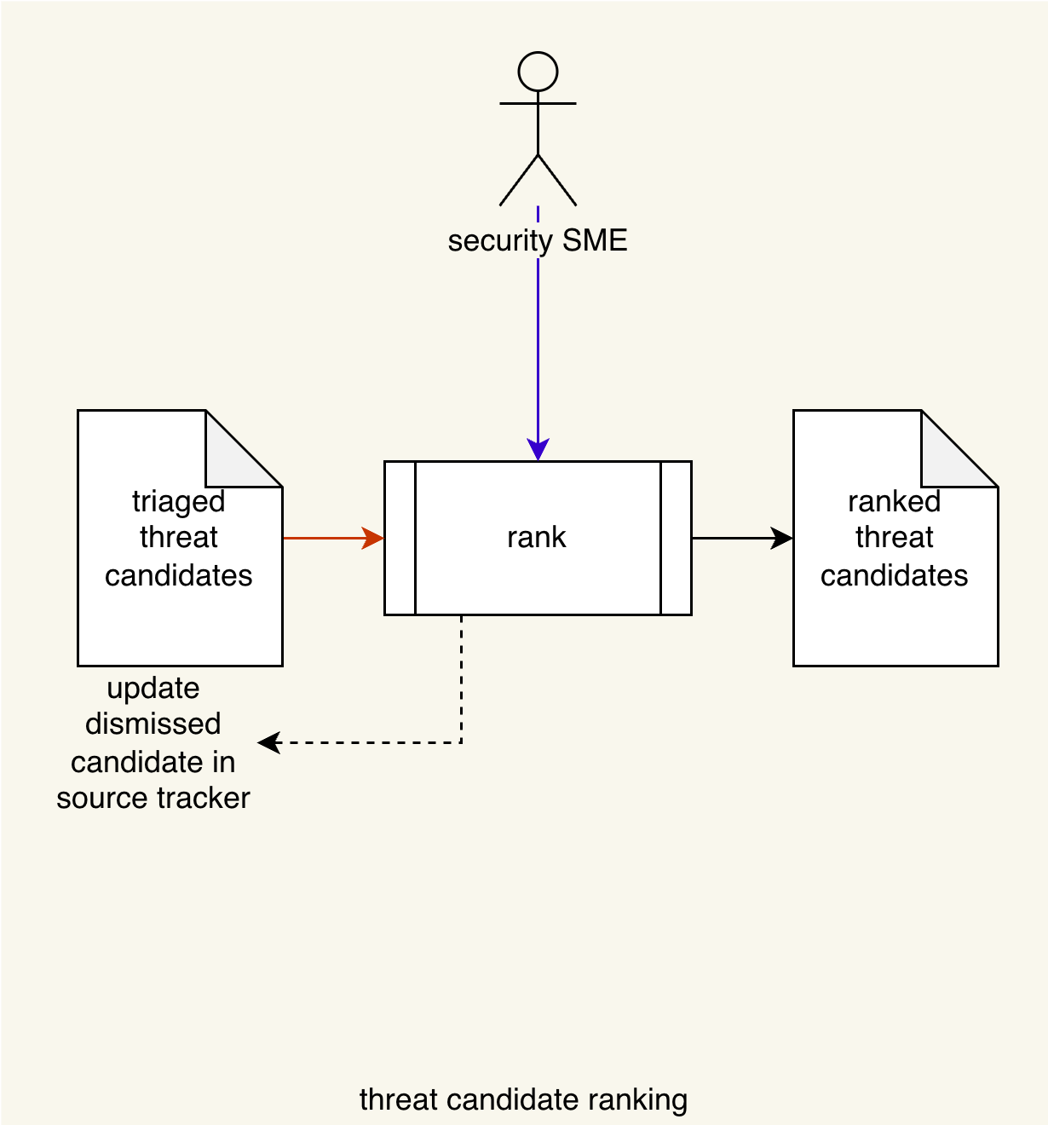
The security SME takes the triaged threat candidates and conducts a ranking on them to establish the likelihood of each. This produces a list of ranked threat candidates. Any threat candidates which are determined to be invalid are dismissed, and its source tracker is updated accordingly.
Note: A standard rubric should be used for determination of the threat likelihood.
Note: Some threat candidates may already have a likelihood provided. This is usually the case there the threat candidate comes from an outside source, such as a researcher or cybersecurity monitoring of vulnerability reporting databases. In these cases, the provided likelihood (numeric or quantized) will need to be mapped into the organizations quantization.

Methodology
The recommended methodology for this activity is as follows:
- Select a likelihood rubric
- Encode the rubric quantization bands
- Encode the domain quantization bands
- Enumerate the threat candidates with minimal necessary details
- Provide a worst case scenario for each threat candidate
- Compute and record the rubric value and metadata for each threat candidate
- Provide notes where appropriate

Discussion
This section provides additional information to assist in performing this activity.

Likelihood Rubric
The rubric used to determine a threat candidate’s likelihood should be appropriate to the nature of the threat.
Some common rubrics are:
Rubric |  | Application
CVSS ^{[5]} | Common Vulnerability Scoring System | Defects in implementation
CCSS ^{[6]} | Common Configuration Scoring System | Defects in configuration
CMSS ^{[7]} | Common Misuse Scoring System | Unintended use cases
A more general rubric is presented in tables G-2 – 4 of NIST SP 800-30 Guide for Conducting Risk Assessments ^{[9]}. Table G-5 of the same document shows how to create an overall likelihood by combining the results from the other tables.
Note: Use of a purely quantized rubric (such as presented in NIST SP 800-30) can greatly simplify the threat prioritization process. It is highly recommended for organization where there is little history of formal cybersecurity threat prioritization.

Likelihood Value and Quantization
When the chosen rubric generates a numeric value, it is useful to quantize that value in order to simplify the eventual determination of whether the threat candidate is controlled or uncontrolled.
The first three rubrics mentioned (CVSS, CCSS, and CMSS) produce a numeric score (value) which in the range [0,10]. They also provide a quantization shown below.
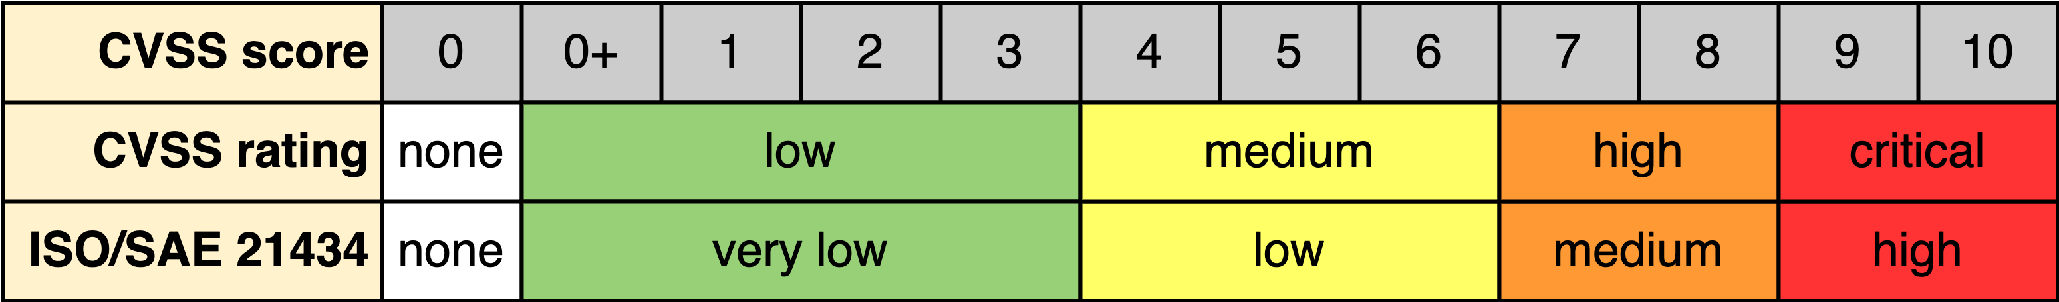
Note: The quantization for CCSS and CMSS is the same as for CVSS.
The use of quantization enables a simpler mechanism for processing the threat candidates in later activities.
Note: A true zero value and none quantization have been added in order to make it easier to implement automation.
Because a domain may have specific requirements regarding the documentation of likelihood (and in later activities, severity quantization), it is important to establish a mapping between the chosen rubric and domain quantization.
For example, if we consider the automotive domain, ISO/SAE 21434 Road vehicles – Cybersecurity engineering ^{[8]} specifies a likelihood (attack feasibility rating) quantization list (very low, low, medium, and high), shown below mapped to the CVSS rating.

Since ISO/SAE 21434 does not specify the value ranges (bands) for the quantization, they have been mapped to align with the ones provided for CVSS.
It is important to document the rationale for establishment of a mapping between the chosen likelihood rubric and domain quantization.
Note: As above, a true zero value and none quantization have been added in order to make it easier to implement automation.

Worst Case Scenario
Most product cybersecurity threat candidates are identified at a level far below that of the system level. Because of this, it is extremely helpful to provide a possible system-level worst case scenario that may occur if a threat candidate is realized. This greatly assists the risk SME who will be providing a severity for the threat candidate in the context of the system itself. The risk SME should be able to readily determine whether the threat candidate has applicability to their risk domain.

Threat Candidate Ranking Template
The threat candidate ranking may be documented using the AVCDL threat candidate ranking template Microsoft Excel workbook ^{[3]}.
Note: Other forms of documentation are permissible so long as they provide the information laid out in this document.
Note: This template assumes the use of a likelihood rubric that generates numeric values. When a purely quantized rubric is used, the template may be simplified accordingly.
There workbook contains the following sheets:
- Cover sheet
- Revision history
- Reference documents
- Ranking
- Rubric quantization
- Domain quantization
- Legend
These will be addressed in turn.

Duplication of Rows in the Various Sheets
When there is the need to add rows to the various sheets of the workbook, be sure to duplicate an existing row. This is because validation checks and inter-sheet lookups may be attached to some of the cells which enables the use of dropdown lists and auto-population.

Cover Sheet
The cover sheet of the workbook is shown below:
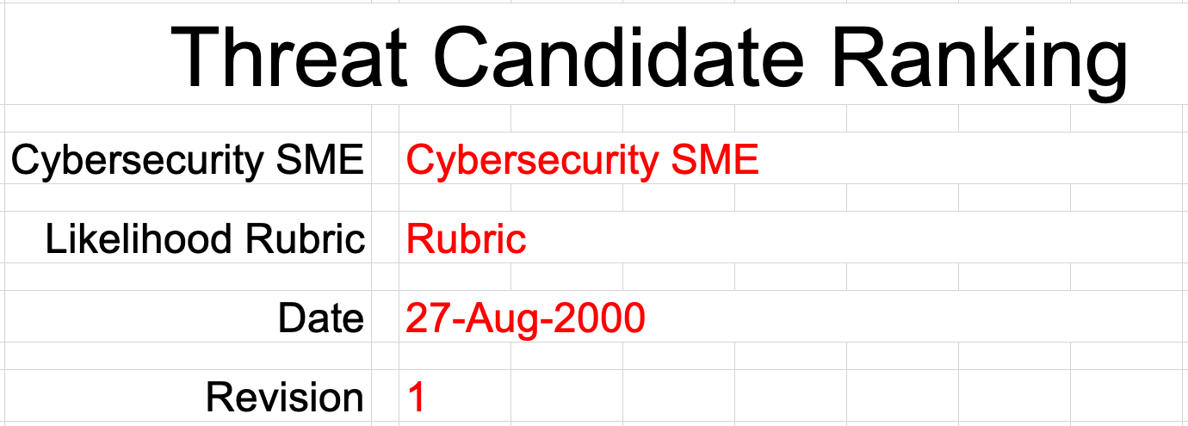
Fields to be completed are shown in red.

Cybersecurity SME
This is the cybersecurity subject matter expert creating the threat candidate ranking list.

Likelihood Rubric
This is the name of the rubric used to determine the threat candidate’s likelihood.

Date
This is the date when the document was created or updated. The date should be updated whenever the document is updated.

Revision
This is the revision number of the document. The revision number is a monotonic and increasing integer, starting at 1. It should be incremented every time the document is updated.

Revision History
The revision history sheet of the workbook is shown below:
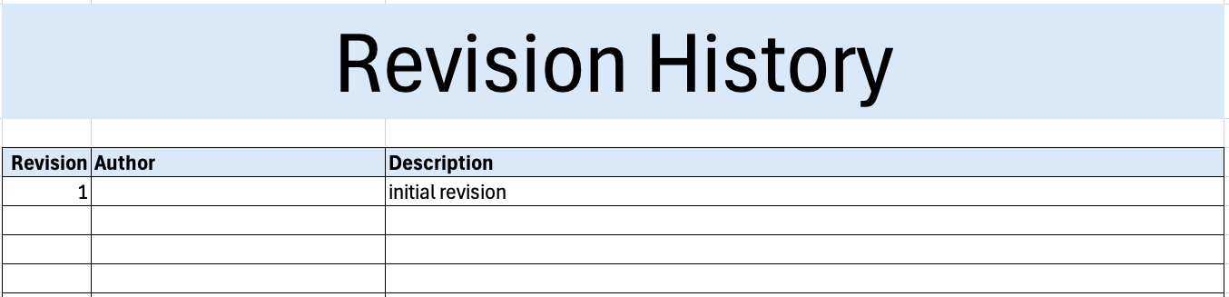

Revision
The revision corresponds to that listed on the cover sheet.

Author
The author corresponds to the cybersecurity SME listed on the cover sheet.

Description
This is a brief description of changes made to the workbook since it was last updated.

Reference Documents
Note: These references are those necessary for the creation of the threat candidate ranking list.
Note: References to information for both the rubric used and domain quantization should be included.
These entries are shown in red.
The references sheet of the workbook is shown below:
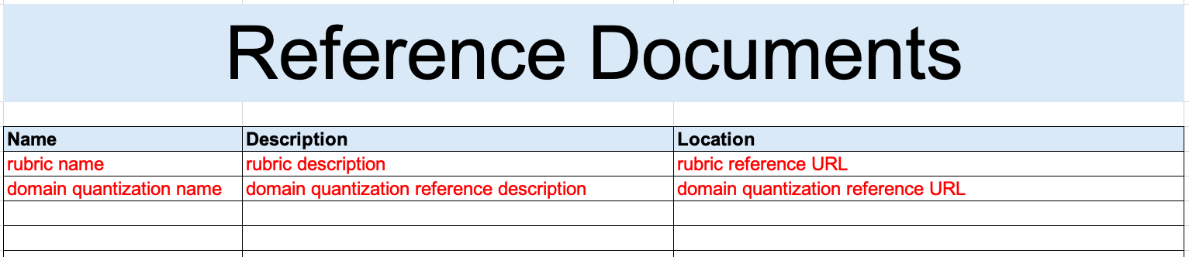

Name
This is the name of the document being referenced.

Description
This is a brief description of the document being referenced.
Note: In cases where the reference material is expressed in the form other than a document (for example, a web page), this should be noted.

Location
This is the location of the document being referenced. It may be a physical location or a URL.

Ranking
The ranking sheet of the workbook is shown below:
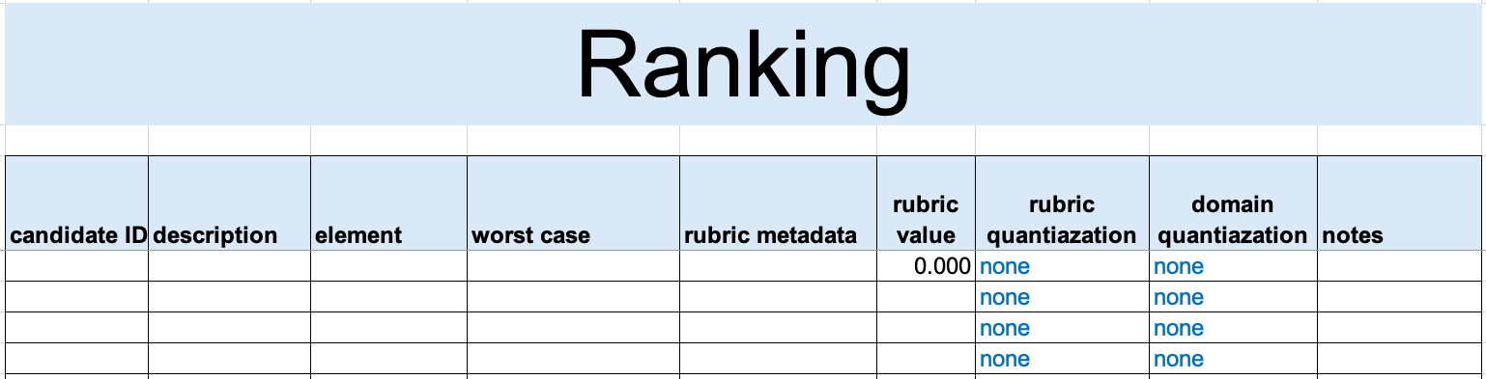

Candidate ID
This is the unique ID of the threat candidate.
Note: This value should be copied from the triage output providing input to this activity.

Description
This a description of the threat candidate.
Note: This value should be copied from the triage output providing input to this activity.

Element
This is the name of the element within the system where the threat candidate originates.
Note: This field is provided to give context to the threat candidate.

Worst Case
This is a worst case scenario assuming the threat is realized.

Rubric Metadata
This is a text representation of the inputs (parametrics) needed to replicate the rubric’s output value generation.

Rubric Value
This is generated output from the likelihood rubric.

Rubric Quantization
This is the quantization of the likelihood rubric’s output value as defined by the rubric.
Note: This field is auto-populated based on information in the rubric quantization sheet.
This field should not be altered manually.

Domain Quantization
This is the quantization of the likelihood rubric’s output value as mapped into the target domain.
Note: This field is auto-populated based on information in the domain quantization sheet.
This field should not be altered manually.

Notes
This is a general notes field.

Rubric Quantization
This sheet provides translation between the rubric value and its quantized representation.
Label selection is based on the bands minimum value, eliminating the need for including an upper bound.
The rubric quantization sheet of the workbook is shown below:
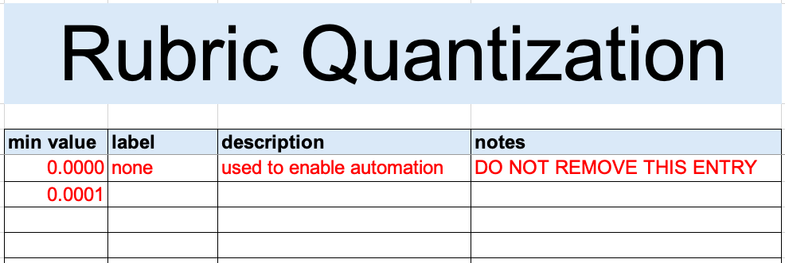
Note: A true zero (none) entry is pre-populated in order to support automation.

Min Value
This is the minimum value of the quantization band.
Note: The second entry pre-populates this value to be slightly greater than the ‘none’ band.

Label
This is the name of the quantization band.
Note: This column is used to populate the rubric quantization field on the ranking sheet corresponding to the rubric value entry.

Description
This is the description of the quantization band.

Notes
This is a general notes field.

Domain Quantization
This sheet provides translation between the rubric value and the target domain’s quantized representation.
Label selection is based on the bands minimum value, eliminating the need for including an upper bound.
The domain quantization sheet of the workbook is shown below:
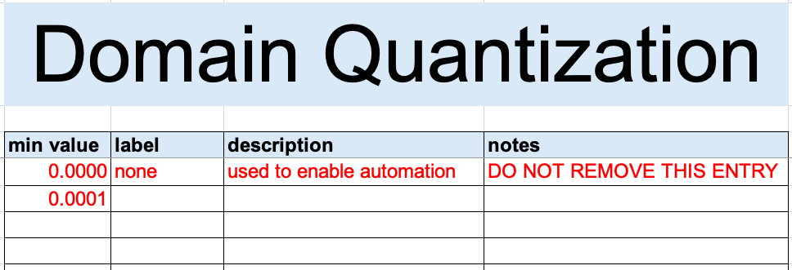
Note: A true zero (none) entry is pre-populated in order to support automation.

Min Value
This is the minimum value of the quantization band.
Note: The second entry pre-populates this value to be slightly greater than the ‘none’ band.

Label
This is the name of the quantization band.
Note: This column is used to populate the domain quantization field on the ranking sheet corresponding to the rubric value entry.

Description
This is the description of the quantization band.

Notes
This is a general notes field.

Legend
Note: This workbook does not use the legend sheet.

Exit Criteria
This procedure is considered complete once the ranked threat candidates list has been generated.
Note: This activity does not generate any materials used as documents of record.

References
- AVCDL (AVCDL primary document)
- Theat Prioritization Plan (AVCDL secondary document)
- AVCDL Background Material (AVCDL elaboration document)
- AVCDL threat candidate ranking template (AVCDL template)
- Common Vulnerability Scoring System
https://www.first.org/cvss/
- The Common Misuse Scoring System (CMSS): Metrics for Software Feature Misuse Vulnerabilities
https://tsapps.nist.gov/publication/get_pdf.cfm?pub_id=910230
- The Common Configuration Scoring System (CCSS): Metrics for Software Security Configuration Vulnerabilities
https://nvlpubs.nist.gov/nistpubs/legacy/ir/nistir7502.pdf
- ISO/SAE 21434:2021 Road vehicles – Cybersecurity engineering
https://www.iso.org/standard/70918.html
- NIST SP 800-30 r1 – Guide to Conducting Risk Assessments
http://dx.doi.org/10.6028/NIST.SP.800-30r1

